FORD COLLEGE COMMUNITY CHALLENGE
REQUEST FOR PROPOSALS (RFP)

INTRODUCTION

The Ford College Community Challenge is a grant-making initiative designed to empower students at higher education organizations to bring about change through community-building projects aimed at addressing urgent local needs. At Ford, we understand that to be a truly sustainable organization, we must play an active role in the larger community, helping address a wide range of vital issues from education to safety to mobility. Ford College Community Challenge requests proposals for community-based projects that must address, in a fresh and creative way, a tangible, unmet need among the following topic(s) surrounding the theme Making Lives Better:

- Building Sustainable Communities
- Driving Social Mobility
- Changing the Way People Move Through Smart Mobility

Through Ford College Community Challenge, Ford Motor Company Fund (Ford Fund) supports universities as they work with students to design and develop programs and initiatives that address critical community needs in new ways, with a focus on helping the community become a more sustainable place to work and live. It is our hope that participating students will find their creativity and resourcefulness engaged in meaningful and unexpected ways.

In Spain we are running Ford College Community Challenge in collaboration with the association Apadrina la Ciencia.

Up to 3 winning proposals will be selected to receive €5,000 each from Apadrina la Ciencia to support implementation of the proposed projects. Winning proposals must, at a minimum:
1. Describe an innovative approach to Making Lives Better
2. Involve students in a leadership role
3. Seek to address an urgent and unmet community need in a tangible way
4. Involve a community-based organization as a partner
5. Involve University faculties as relevant for the project

Each of these areas will be expanded in this “Request for Proposal” (RFP) over the coming pages.

This RFP does not commit Apadrina la Ciencia, Ford Fund or Ford Motor Company, to accept proposals or contracts for service or pay the cost incurred in the preparation of a response to this RFP.

Students and student organizations responding to this RFP must work with their university to gain their agreement to apply for, and serve as, the fiduciary organization for this grant. The university fiscal officer must be notified of the submission. All submissions should be made in English.

PROGRAM SUMMARY

PROGRAM DESCRIPTION

- Objectives: Ford College Community Challenge is a special initiative of Ford Fund. Its purpose is to challenge university students to partner with their local communities to design innovative, student-led projects that address critical community needs which are consistent with charitable purposes.

PROGRAM SPECIFICS

- Summary: Applicants should be pre-graduated students enrolled at any of the public universities of Spain. Participating universities and student-led teams will work with their local communities to create innovative proposals utilizing the university’s resources and capacity to address a need in the community. Proposals must address the theme of the challenge—Making Lives Better —in some way. Up to 3 winning proposals will be selected to receive a one-time, €5,000 grant from Apadrina la Ciencia to implement their proposals.

- The theme: Making Lives Better. In this challenge, proposals must address one of more of three broad areas including Building Sustainable Communities, Driving Social Mobility and Changing the Way People Move Through Smart Mobility. “Mobility” is not restricted to vehicles and/or transportation and a “sustainable community” is not restricted to environmental concerns. Instead Ford C3 uses these terms to describe healthy, liveable communities that are poised to thrive in a global economy.

- For your convenience, downloadable proposal and budget templates are available on the website, www.fordc3c.com/contest. Proposals must be received on or before the close of business, November 30th, 2022 by 5 p.m. CET. Proposals received after the deadline will not be considered. Please submit all required documents to fordscholars@campbellmarketing.services

- Note: The project must be consistent with charitable purposes. Given this initiative is supported by Ford Fund (foundation) dollars, any proposed project must be consistent with a charitable purpose. These purposes include, but are not limited to, combating community deterioration and juvenile delinquency; lessening neighbourhood tensions; reducing unemployment and underemployment; engaging in related activities in relief of the poor, the distressed or the underprivileged; or any other charitable purpose.

- Criteria: Project proposals must meet the following criteria for consideration:

- The project must describe an innovative approach to Making Lives Better. Ford Motor Company Fund is looking for college students to create interesting, unique, and ingenious approaches to defining tangible ways to make lives better in their communities. The more creative the better. Potential areas of focus include (but are not limited to):

- Smart Mobility: How are affordable, clean, and safe transportation systems for the 21st Century designed and implemented? How are lives improved by the way we move?

Ideas may include creating ride share apps, replacing old models of transportation, using data science and analytics to anticipate customer wants and needs.

- Social Mobility: What tool or project for individuals, households or people will aid movement within the layers of social strata?

Ideas may address tools or methods to improve economic empowerment, such as engaging youth to participate in STEAM fields/activities, helping first-generation college students succeed in school, teaching food sustainability and urban gardening to an economically challenged community, increasing access to housing and educational opportunities.

- Environmental Sustainability: Clean water and air are critical to the overall health and wellbeing of a community. How do individuals and organizations in a community learn to become more environmentally conscious and sustainable?

- Sustainable Urban Design.

- Creative approaches to the conservation, or use, of water.

- Student volunteer programs that partner with local non-profits in new ways.

- Education and Training: In an increasingly global economy, human capital is perhaps the most important ingredient to a community’s ability to survive and thrive.

- Safety: What is a safe community? How have the internet and technology changed the definition?

- The project must involve students in a leadership role. University students must be involved in a leadership role in the project, and in all aspects of the project from design to implementation. Successful proposals will demonstrate this involvement in detail.

- The project must seek to address an urgent and unmet community need in a tangible way. Ford C3 is not looking for research studies or reports. Successful proposals will describe a project touching the community in meaningful ways and makes an improvement with the local community. While research/study can and should be a part of any project, meaningful and demonstrable action is required.

- The project must involve a community-based organization as a partner. Winning proposals will demonstrate an active and meaningful partnership with a local community-based organization. The term "community-based organization" is not used as a legal term, but rather to describe any organization that plays a role in the life of the local community (e.g. schools, social service agencies, businesses, government entities).

- The project must involve different University faculties as relevant. It is preferable to involve students from different faculties as relevant for the project so ensure that expertise and experience in different subjects is both leveraged and gained.

- Project Resources and Strategies. Additional consideration will be given to proposals that:
  - Leverage additional community resources, monetary or human, to support the proposed project;
  - Use Apadrina la Ciencia/Ford Motor Company Fund money efficiently to extend the life of the project;
  - Create initiatives that can be sustained after Ford Motor Company Fund money has been incorporated into the project.

- Communication and Publicity. Proposals should include a brief section addressing how the university will communicate and/or publicize the project through various outlets (e.g. press release, web, local television and print, video, social media URLs, etc.)

BUDGET

For budgeting purposes, proposals should assume a one-time grant of €5,000 from Apadrina la Ciencia (up to 3 winning proposals will receive this grant amount). Additional financial resources brought to the project should be clearly identified and described. Please use the template provided.

ROLLOUT

- The process of soliciting proposals from participating schools will be a standard RFP process. This RFP provides all the requirements of the Challenge, and specifies the proposal format and issues to be addressed.
- Selection is based on how well proposals meet the five criteria outlined in this RFP.
- A Review Team made up of Apadrina la Ciencia, Ford Motor Company Fund and Ford Motor Company representatives will score the proposals based on a prepared RFP scoring sheet, discuss the rankings and agree on the winners. The decision of the review team will be final.
- Winning universities will be presented with their grant awards and will then have a set amount of time (normally over a year) within which to implement their projects.

TIMELINE

- July 20th, through November 30th, 2022, 5 p.m. CET: Proposals
- December 2022: Winners publicly announced
- January 2023 through December 2023: Projects implemented

The exact timing of the announcement events and project implementation period will be negotiated on an individual project basis.

PROPOSAL SPECIFICS

The Competition Application
Proposals will be accepted from all qualified applicants (as described in this RFP) in English. These initial proposals should utilize the templates provided on the Ford Blue Oval Network site, www.fordc3c.com/contest . Proposals should address the following areas:

- Introduction and Project Summary
- Description of How Project Meets Each of the Ford C3 Criteria
  - The project must describe an innovative approach to Making Lives Better in one of three broad categories: Changing the Way People Move Through Smart Mobility, Driving Social Mobility or Building Sustainable Communities
b. The project must involve students in a leadership role
c. The project must seek to address an urgent and unmet community need in a tangible way
d. The project must involve a community-based organization as a partner
e. The project must involve students from University faculties as relevant
- Project Resources and Strategies
a. Will the project be sustainable after Ford Motor Company Fund monies are completed?
b. Can additional resources be identified and leveraged?
c. Are there any strategies for extending the life of the initiative?
- Budget
- Timeline

The presentation of a video describing the project is recommended, but optional.

Please visit the www.fordc3c.com/contest to download the templates that should be used to create proposals and budgets for this competition.

AWARD STRUCTURE AND ROLLOUT

GRANT AWARD PROCESS

Ford College Community Challenge is an initiative of the Ford Motor Company Fund and is being run in Spain with non-profit partner Apadrina la Ciencia. Proposal entries will be judged by the criteria listed in this RFP, and up to 3 winning proposals will be funded. Once the winning teams have been announced the University will receive the grant from Apadrina la Ciencia, which has to be used for project implementation

PARTICIPANTS’ PERSONAL INFORMATION

Participants’ Personal Information collected is subject to the Privacy Statement located on www.fordc3c.com/privacy-policy. By participating in the Ford College Community Challenge, you expressly agree to the terms of the Privacy Statement.

Q&A

Participating students can direct their enquiries to Apadrina la Ciencia by contacting apadrinalaciencia@gmail.com

PROPOSAL SUBMISSION PROCEDURES

For your convenience, downloadable proposal and budget templates are available on www.fordc3c.com/contest.

Proposals must be received on or before the close of business, November 30th, 2022 by 5 p.m. CET. Please ensure you fill out the application in English. Proposals received after the deadline will not be considered.

Please submit all required documents to fordscholars@campbellmarketing.services

EXAMPLES OF WINNING PROPOSALS

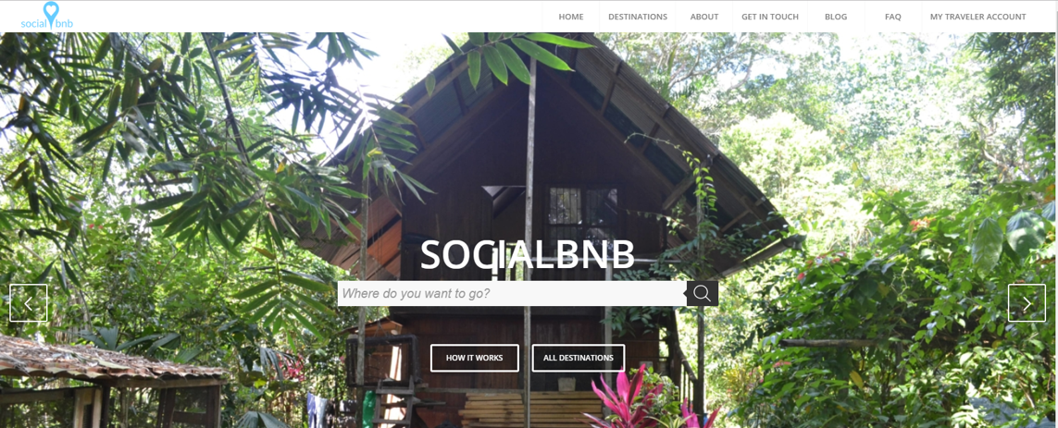

Socialbnb, a project from students from the University of Cologne, is an online platform that connects the growing number of travellers with NGOs that offer unused rooms as temporary homestays. The innovative approach aims at stabilizing the cash flow of NGOs. This reduces their donation dependency sustainably, thus increasing the long term success of their aid projects.

Furthermore, the NGOs are provided with a global platform to raise awareness for their cause. An NGO –for example, a local English school in a village in Cambodia –can list their unused bedrooms as a homestay on the Socialbnbwebsite.

Any traveler visiting socialbnb.org can now book an overnight stay at homestays powered by the NGO. Socialbnb.org shows the homestay and its merits as well as the profile of the NGO. It features the aid project the traveller will be supporting by staying at the homestay–in this example the tourist finances the English teacher.

Every project states specific financing goals to ensure high levels of transparency. This way, the visitors immediately see which cause they will be supporting. The benefit for the tourist is a unique and authentic way to experience the country while doing good for local communities. By supporting the aid project, every tourist shapes the local community in a much-needed way. In the future, the homestays powered by an NGO will be a real alternative on the accommodations market.

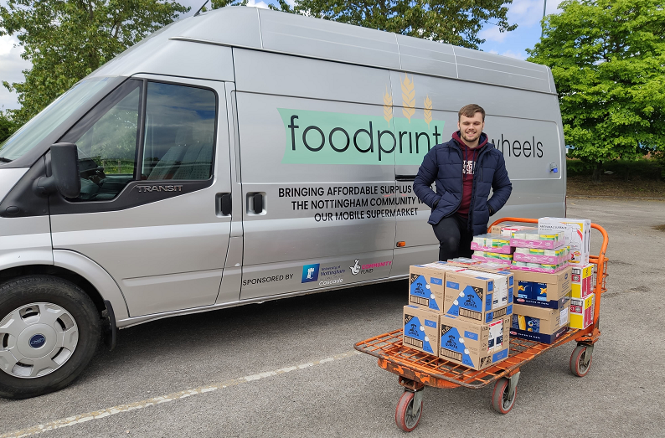

Foodprint was created by students at the University of Nottingham to tackle the problems of food waste and food poverty in Nottingham, acting as an intermediary between supermarkets, wholesalers, charities, and the people of Nottingham. Foodprint collects food from partners that would otherwise go to landfill and takes it to their social supermarket in Sneinton.
From there, the food is sorted and redistributed to those experiencing food poverty in the city, be this through the network of community-eating cafes, food banks, and school breakfast clubs. The food that is not redistributed is sold in their shop at extremely discounted prices, making good food accessible and affordable.
Since the shop’s opening in December 2017, they have made a big impact and this is increasing all the time. In 2019 – they saved 34,000kg of food from landfill, redistributed over 2,700kg, saved 117,000kg of CO2, impacted over 744 individuals each week, recruited over 25 active volunteers.
Due to the COVID-19 crisis, the Foodprint team wanted to do everything they could to relieve some of the pressure on the community. Using a recently renovated van, Foodprint on Wheels was able to provide food bundles to retirement homes and deliver necessary supplies to those unable to provide for themselves during this difficult and unprecedented time.

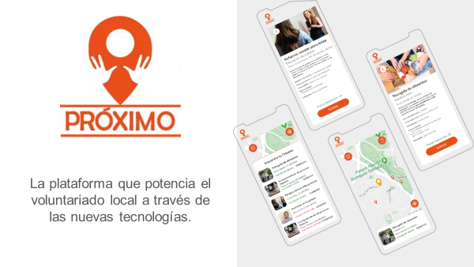

Proximo is a project from a student team from the UAM Madrid. Its focuses on connecting Volunteers and NGOs to maximize social impact

Having worked with several NGOs to help on volunteering initiatives, it is clear that there are numerous social actions which are not being carried out, due to the lack of volunteers. Although people are willing to help, this becomes difficult to achieve because of the inefficient transmission of information about the social needs surrounding them.

This project plans to connect people who are seeking volunteer opportunities with NGOs that are looking for volunteers for specific projects. The proposal includes the generation of a mobile application where volunteers can find various social activities based on geolocation. Activities will be filtered by time preferences (date and duration), volunteer experience and the type of skills required.

This is a unique approach in Spain, since we are not only connecting people with NGOs, but also connecting volunteers’ skills with the person of the NGO in charge of one specific social activity of a specific duration, on a specific date, on a specific place. The aim is to become the “The Volunteering Tinder” of our city - “Making it easy to transform your time in time to offer”.

